KARISHMA PATIL  Personal Data:  Father’s Name: MADHUKAR PATIL.  DOB : 15 May 1994  Sex : Female.  Nationality : Indian  Languages Known : English, Hindi & Marathi.  Email:  Kari.p1505@gmail.com  Contact No.  +91-9403250135  Present Address:  Gala-Jai,tulja bhawani chowk, Harsul, Aurangabad.  Pin – 431003.  Technical Skills:  Basic C, HTML, ASP.NET, RFT, RQM, QTP, SQL Queries.  PROJECT:  Wi-Fi Based Notice Board Using Android Application, Online Shopping Mall.  Hobbies :  Listening Music.  Trekking. | Career Objective: 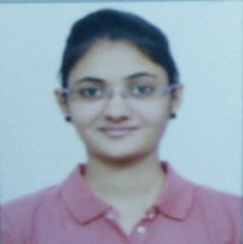  To work in challenging environment, utilizing my current knowledge, with many learning opportunities and become a successful Engineer.  Professional Qualification:  College Name: MGM’s JNEC, Aurangabad.  Branch: COMPUTER SCIENCE ENGINEERING.  Extracurricular Activities:  - ISTQB Certified (Foundation level)  - Involved in Manual Testing of Applications.  - National Services Scheme (NSS) Candidate.  Personal Skills:  I am self-motivated and dedicated. I can easily adjust myself in the surrounding environment. I always try to make good changes in myself.  I try to learn good things from others.  Declaration:  I hereby declare that the above-mentioned information is correct up to my knowledge and I bear the responsibility for the correctness of the above mentioned particulars.  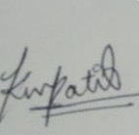  Signature ( KARISHMA PATIL)
  Year | Year Of Passing | Percentage | Grade
  BE | May/June 2016 | 65.15% | First Class
  HSC | 2012 | 64.55% | First Class
  SSC | 2010 | 84.55% | Distinction

